NATIONAL STABLEFORD 2024
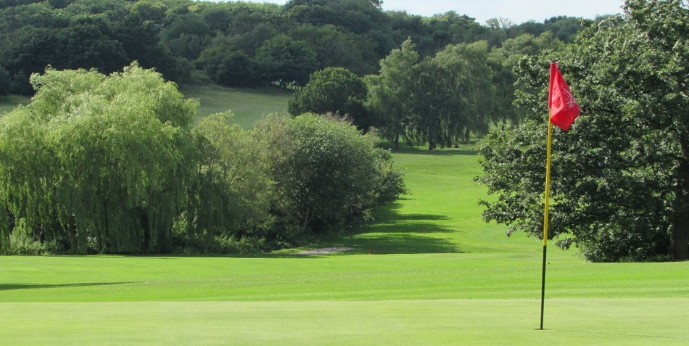
NEW EVENT FOR 2024 GOLF SEASON

ALL PLAYERS WELCOME 18.1HANDICAP INDEX AND ABOVE.
TWO ROUNDS ON THE 3RD AND 4TH OF SEPTEMBER 2024
AT BEARSTED GOLF CLUB, MAIDSTONE, KENT
PLAYED FROM FSUK CHAMPIONSHIP YELLOW TEE MARKERS.
STABLEFORD FORMAT WITH BOTH SCORES TO COUNT.
INITIAL ENTRY 3 PLAYERS PER SECTION.
PRIZES FOR BOTH COMPETITION DAYS.

WINNER TO BECOME NATIONAL STABLEFORD CHAMPION.
WINNERS TROPHY
PLEASE CONTACT EVENT ORGANISER RICHARD ELSON
KENT FRS FOR MORE DETAILS
Richard.Elson@kent.fire-uk.org

