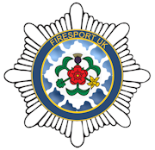
FIRESPORT UK
National Pairs Championship 2024

Rotherham G.C
Thrybergh, Rotherham S65 4NU

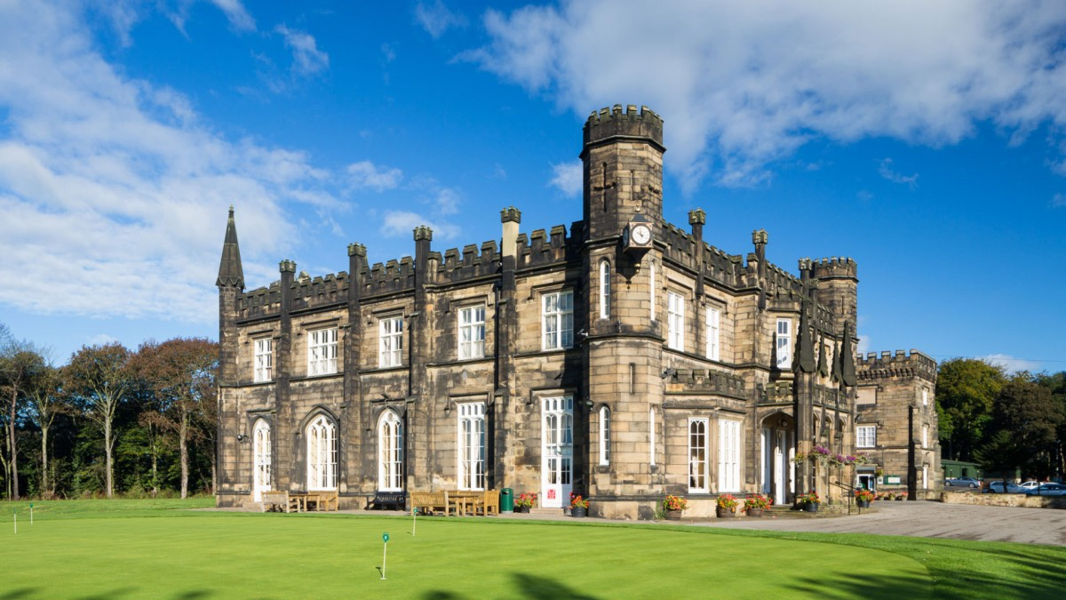

Introduction
The 2024 Fire Sport UK National Pairs Championship will be proudly hosted by South Yorkshire F&R and contested at Rotherham GC.
The Course: Par 70, 6378 yards, Slope 134….Rating 72
• Designed by Sandy Herd, opened in 1903, remodelled/modified by 5-time Open winner James Braid
• Hosts the Lee Westwood Trophy, who’s past winners include David Horsey and Gary Wolstenholme
• Masters Champion Danny Willett is a member and there is a ‘Willett’ Bar area full of memorabilia
Dates: The competition will be played over the 14th, 15th, 16th July 2024.
Closing date for entry 27.05.2024……..(2nd team or more option available dependent upon demand)
FORMAT OF COMPETITION
Pairs Betterball Medal……. 85% allowance
36 holes……. two rounds of 18
14.07.24 – Practice Round
Day One – First Competition Round Played from FSUK Championship tee’s (White)
Day Two – Second Competition Round Played from FSUK Championship tee’s (White)
HANDICAPS (max handicap index. 18.0)
WHS index to be provided at registration for National Events, Golf Club, or brigade ‘handicap master’ index and have it present for scrutiny by the organising committee on the practice day at the very latest. A handicap certificate handed in on the competition day will not be accepted.
Failure to provide evidence will fall into three stages:
1. No penalty for no Fire Service golf evidence on the first occasion, club scores should be available to see.
2. To play off scratch on the second occasion of no evidence.
3. Unable to compete at the next National fire service event.
Club golfers will manage their own handicap index at Fire Service Golf Events, this to include local, regional, and national events. When entering a National Competition upon registering you ‘MUST’ submit your card into the ‘My England Golf’/ Igolf app’.
Non-England registered players ‘will take their cards back to their golf clubs and submit them.’ The committee will carry out random checks, anyone winning a prize will automatically be checked, if their card has not been submitted, they and their team will be disqualified, prizes/trophies will be awarded to the next in line. The player will not be allowed to enter the event the following year.
As the National Pairs is a FSUK Golf Section event, players will, if he/she have one, play off their club handicap. Any player who does not have a club handicap will play off their Brigade Golf Section (Society) Handicap Index. All Society handicaps must be supported by the Handicap Master system.
The maximum playing handicap index for the competition shall be 18.0 at the time of submitting the entry form. Should a team members’ handicap index increase above 18.0 by the time of the competition, the organising committee must be informed. That entry shall be accepted subject to that member playing off 18.0 handicap index.
Any team found to contain a player whose handicap index is above the limit set out above (and had not informed the organising committee) or whose handicap does not comply with National guidelines shall be disqualified from the competition.
IN ADDITION, THAT BRIGADE WILL BE DISQUALIFIED FROM ENTERING A TEAM INTO THE FOLLOWING YEARS’ COMPETITION.
Playing Handicap allowance 85% of Course Handicap
Practice Rounds
Practice Rounds can be booked directly with the Pro Shop, quote ‘Fire Service Pairs’. Please be aware that tee times are available for the practice round on Sunday 14th July from 12.30. However, the club will allow practice rounds in the weeks leading up to the competition dependent upon availability and at the club's discretion.
Tel….01709 850 466
Tee Times
A full list of Tee times will be sent out nearer the time after all entrants are declared.
Practice Facilities
The club has a full range of practice facilities including driving range, chipping, and putting greens as well as a practice bunker and 2 nets.
Golf facilities
Facilities are available, changing rooms, showers, lockers, etc.
Fully Stocked Pro Shop
Dress Code
The club expects all players to be appropriately dressed at all times. Meal after the final round will be smart/casual.

National Pairs Cost
3 rounds of Golf with food pre and post play on the competition days is £140.00 pp. This amount covers entry to ALL aspects of the 2 days play as well as the Firesport Golf Section levy.
Bank transfer (preferred) to: SYF&R Golf Section…. ref Nat Pairs
Account Number: 39330923 Sort Code: 52-30-50
Cheques made payable to; SYF&R Service Golf Section…ref Nat Pairs
Postal Address: 39 Pitt Street, Mexborough, South Yorkshire S64 0LT
Please ensure a reference name is clearly stated if using bank transfer, if posting a cheque then please add a short covering note.
E-mail: fraermegan7@gmail.com
Tel: Grant Morrow 07786636211

FIRESPORT UK
National Pairs Championship 2024

Fire and Rescue Service
Contact Name
Contact Address
Contact Number
Contact e-mail
Player 1 Name | Handicap/CDH |  | Dietary Requirements
Player 2 Name | Handicap/CDH |  | Dietary Requirements

Second Team required Yes/No

