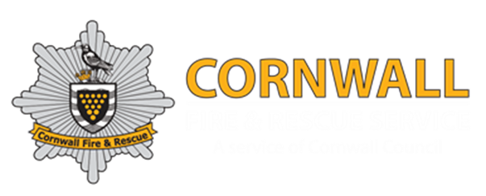
Cornwall Fire and Rescue Service Golf Section
National Pairs – Prize Winners

2’s winners
There were 20 2’s

Day 1
4th Hole
Mark Sanders
Gary Marsh
Chris Coxon
Paul Hesford
6th Hole
Micky Keepin
Day 2
1st Hole
Paul Adams
Martyn Cleverly
4th Hole
Kev Lilley
Phil Hoare
Mark Henwood
Bradley Barnes
Kev Sirey
6th Hole
Gareth Hawkes
Nick Bird
8th Hole
Jamie Pridd
16th Hole
Lee Schofield
Mick Tait
Ady Thompson
Jamie Pridd
Barry Pond

Day 1
Prizes | Player 1 | Player 2 | Score | FRS
Nearest Pin 6th | Simon Athey | N/A | N/A | South Yorkshire
Nearest Pin 16th | Gareth Hawkes | N/A | N/A | Avon
Best Net | Mark Henwood | Lee Griffin | 66 | Cornwall
Best Gross | Micky Keepin | Gareth Hawkes | 75 | Avon

Day 2
Prizes | Player 1 | Player 2 | Score | FRS
Nearest Pin 4th | Kev Lilley | N/A | N/A | Nottinghamshire
Nearest Pin 16th | Barry Pond | N/A | N/A | Devon & Somerset
Best Net | Ben Mullen | James Parkinson | 73 | Tyne & Wear
Best Gross | Daniel Walker | Gary Walker | 71 | Oxfordshire

Overall
Prizes | Player 1 | Player 2 | Score | FRS
Best Net | Neil Blackburn | Mark Sanders | 66+64=130 | Devon & Somerset
Best Gross | Mark Carpenter | Dave Hunt | 71+71=142 | Hereford & Worcester
2nd Net | Gary Marsh | Dave Hommershaw | 69+62=131 | Hampshire
2nd Gross | Matthew Thompson | Ady Thompson | 78+70=148 | Nottinghamshire
3rd Net | Lee Schofield | Simon Athey | 66+65=131 | South Yorkshire
3rd Gross | Chris Coxon | Dave Lock | 75+73=148 | Devon & Somerset

