FIRESPORT UK National Golf Section
National Pairs Championship 2019
PERRANPORTH GOLF CLUB
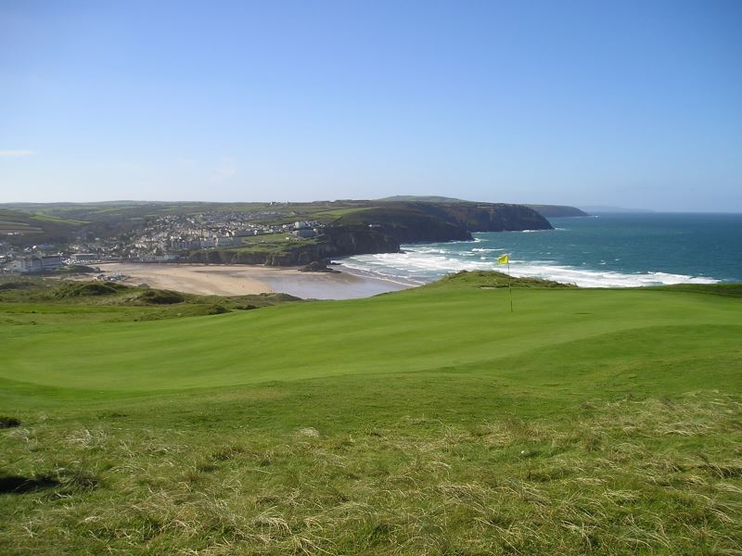
2nd & 3rd May 2019

Cornwall Fire & Rescue Community Safety Service is proud to host
FIRE SPORT UK National Pairs Championship
at
Perranporth Golf Club,
Budnic Hill, Perranporth, TR6 0AB.

The competition is kindly sponsored this year by Fire Angel Products

Perranporth is one of James Braid’s classic links golf courses. Perched on the stunning North Cornish Coast, it makes the most of the landscape with undulating sand dunes.
At 6296 yards this is an exciting par 72 course made tough by the prevailing south westerly wind.

Cornwall Fire & Rescue Community Safety Service are proud to be hosting the National Pairs in 2019 and we look forward to seeing familiar and new faces to an exciting and challenging competition.
Phil Hoare
Golf Society Secretary,
Cornwall Fire & Rescue Community Safety Service,

National Pairs Cost

The event will cost £80.00 per person.
Includes players levy to Firesport golf section. Two rounds of golf on competition golf and evening meals on both days. Bacon Roll and Coffee on Day 2

Cheques made payable to; CCFB Golf Society
All entries to:
Phil Hoare by the 1st of March 2019.
Postal Address: Bodmin Fire Station, Berrycombe Road, Bodmin, Cornwall,
PL31 2NS
E-mail address: Phil.Hoare@fire.cornwall.gov.uk
Tel: 07970 141027/ 07977 047595
For those who wish to pay via BAC Sort Code 30/98/76 Account 36195360.

Entry Form at the end of the document.
Entries on a first come first served basis, (initially1 pairs per fire service) maximum 44 pairs. Any spare places will be announced after the 1st March 2019. These will be allocated to those who express the request for further teams on initial entry form.

Format
The format again will be 36 holes Pairs Better Ball Stroke Play over 2 days
Maximum handicap limit 18, allowance will be 9/10 of competitor’s current playing handicap to a maximum of 16. All players must be in possession, at registration, of a bona fide handicap certificate i.e. club or brigade certificate, failure to produce a certificate will result in that player playing off a scratch handicap (0).
All Society handicaps must be supported with the previous 12 months playing history, this also applies to non-active Club Handicaps. Please provide CDH numbers for golf club members when filling out the entry form.

Accommodation

Perranporth GC can offer limited self-catering accommodation on a first come basis.
The cost on this accommodation will be discounted for the event to £25pppn.
https://www.perranporthgolfclub.co.uk/accommodation

There are 4 Lodges available, sleeping 6 people £150 per night (x2 twin rooms x1 double room x1 sofa bed)
and
5 Caravans sleeping 3 people £75 per night (x1 double x1 twin room)
NB. Accommodation may be sharing with other groups

Book via entry form or contact Phil Hoare, on a first come first serve basis

Itinerary

Wednesday 1st May 2019
Practice round - discounted rate of £15 paid directly to the Club prior to playing
To be arranged through Club Pro Shop 01872 572454 at a cost of £15.00 pp

Thursday 2nd May 2019
1st round of golf
Starting from the 1st Tee from 10.40am
Running evening meal in clubhouse

Friday 3rd May 2019
Bacon roll and coffee on arrival
2nd round of golf - 1st and 10th Tees, starting 8.00am onwards
Evening meal in clubhouse
Followed by prize presentation

Dress Code
The club expect all players to be appropriately dressed at all times.
Meal after first round, dress will be smart/casual - Golf Attire (no jeans)
Meal after the final round, dress will be JACKET & TIE (no jeans)

Practise Facilities
The club have a range of practice facilities including chipping area, putting green and driving range.

Changing facilities
Facilities are available, changing rooms, showers.

The local Area
Perranporth is a busy Cornish holiday resort with a number of local pubs and restaurant’s. We have worked closely with local businesses to ensure you time in Cornwall is an enjoyable event. Once registered, you will be given a locals card to enable you discounts at a number of the local pubs and takeaways.

If you require any further information do not hesitate to contact me

Phil Hoare
Bodmin Fire Station,
Berrycombe Road,
Bodmin,
Cornwall,
PL31 2NS.
Tel:
Work 07970 141027
Personal 07977 047595
Email: Phil.Hoare@fire.cornwall.gov.uk

National Pairs Entry Form 2019
Closing Date 1st March 2019

Fire and Rescue Service
Contact Name
Contact Address
Contact Number
Contact Email

Player 1 Name | Handicap | CDH Number | Dietary Requirements

Player 2 Name | Handicap | CDH Number | Dietary Requirements

Player 1 Name | Handicap | CDH Number | Dietary Requirements

Player 2 Name | Handicap | CDH Number | Dietary Requirements

Player 1 Name | Handicap | CDH Number | Dietary Requirements

Player 2 Name | Handicap | CDH Number | Dietary Requirements

Accommodation required | YES/NO
Number of people requiring accommodation

Please make cheques payable to: CCFB Golf Society
Bank Transfer: - Sort Code: 30/98/76 Account Number: 36195360
Please reference BACS payments using the contact person’s surname.
Postal Address: Phil Hoare Bodmin Fire Station, Berrycombe Road, Bodmin, Cornwall, PL31 2NS. Email: Phil.Hoare@fire.cornwall.gov.uk

