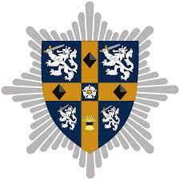

**DURHAM & DARLINGTON FIRE & RESCUE SERVICE**

**ARE PROUD TO HOST**

**THE SHERIFFS CUP 2024**

**THE WYNYARD GC, WYNYARD, STOCKTON-ON-TEES**

**10th-12th JUNE 2024**

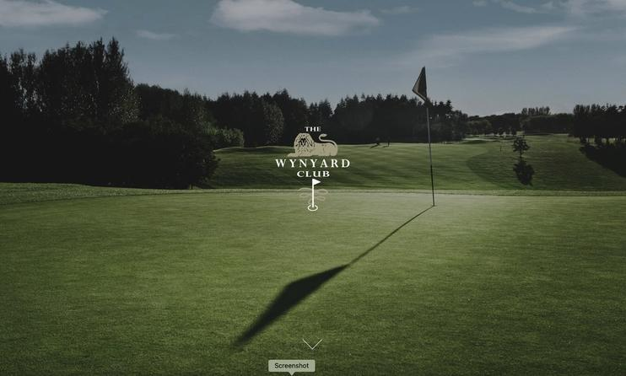

## Set in over 200 acres of rolling parkland and mature woodland on the exclusive Wynyard Estate near Teesside, the Wellington Course at Wynyard Golf Club is rated as one of the UK’s top golf destinations. Stretching 7000 yards from the back tee, this outstanding and highly acclaimed 18-hole, par 72 championship course includes sweeping fairways, panoramic views, elevation changes and over 80 bunkers to challenge the most experienced of golfers.

## 

## Pristine course conditions, all year play, a classic course design with greens and tees that meet USGA performance standards attract both amateur and experienced golfers from far and wide. The course was built in 1996 alongside the building of the Wynyard Estates development and was designed by [Hawtree](https://en.wikipedia.org/wiki/Martin_Hawtree). The Wellington Course has been acknowledged by the [European Tour](https://en.wikipedia.org/wiki/European_Tour) as a high-quality golf course. As a result, Wynyard Golf Club was chosen to host the [2005 Seve Trophy](https://en.wikipedia.org/wiki/2005_Seve_Trophy) between [Great Britain](https://en.wikipedia.org/wiki/Great_Britain) and [Ireland](https://en.wikipedia.org/wiki/Ireland) and [Continental Europe](https://en.wikipedia.org/wiki/Europe).

## The course has also hosted one of the qualifying stages for the European Tour (PQ1). The highest finishers moved on to the next stage before earning the tour cards for the next year. Also, it has hosted Challenge Tour events alongside local charity events.

## 

.

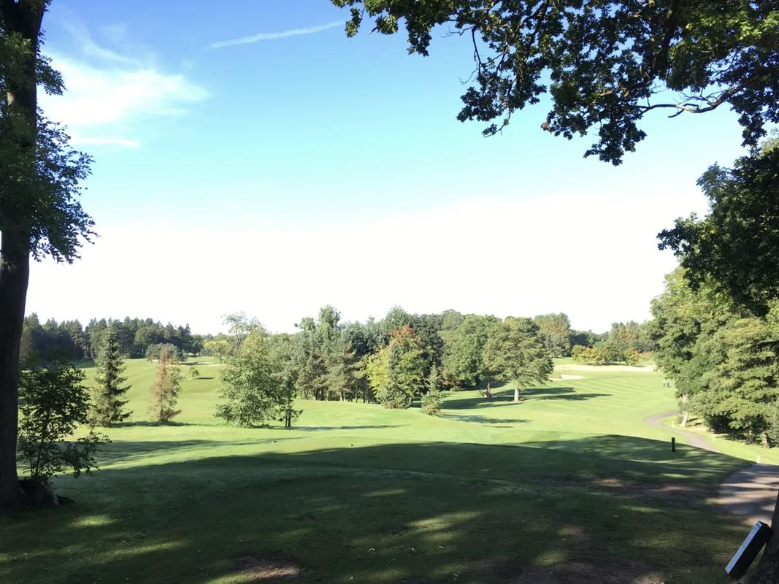

We look forward to seeing you all in June and hope that you travel safe and play well.

**FORMAT OF COMPETITION** 

**Day One** – Practice Round

**Day Two** – First Competition Round (pairs better ball medal 85% allowance). Played from the FSUK Championship tee markers (white)

**Day Three** – Second Competition Round (singles medal 95% allowance). Played from the FSUK Championship tee markers (white)

**HANDICAPS (competition max handicap index. 18.0)**

WHS index to be provided at registration for National Events, Golf Club, or brigade ‘handicap master’ index and have it present for scrutiny by the organising committee on the practice day at the very latest. A handicap certificate handed in on the competition day will not be accepted.

Failure to provide evidence will fall into three stages:

**1 No penalty for no Fire Service golf evidence on first occasion, club scores should be available to see.**

**2 To play off scratch on second occasion of no evidence.**

**3 Unable to compete at the next National fire service event.**

Club golfers will manage their own handicap index at Fire Service Golf Events, this to include local, regional, and national events. When entering a National Competition and registering you ‘MUST’ submit your card into the ‘My England Golf’/ Igolf app’

Non-England players ‘will take their cards back to their golf clubs and submit them’ The committee will carry out random checks, anyone winning a prize will automatically be checked, if their card has not been submitted, they and their team will be disqualified, prizes/trophies will be awarded to the next in line. The player will not be allowed to enter the event the following year.

As the sheriff's cup is a FSUK Golf Section event, players will, if he/she have one, play off their club handicap.

Any player who does not have a club handicap will play off their Brigade Golf Section (Society) Handicap Index. All Society handicaps must be supported by the Handicap Master system.

The maximum playing handicap index for the competition shall be 18.0 at the time of submitting the entry form. Should a team members’ handicap index increase above 18.0 by the time of the competition the organising committee must be informed. That entry shall be accepted subject to that member playing off 18.0 handicap index.   
  
Any team found to contain a player whose handicap index is above the limit set out above (and had not informed the organising committee) or whose handicap does not comply with National guidelines shall be disqualified from the competition. IN ADDITION, THAT BRIGADE WILL BE DISQUALIFIED FROM ENTERING A TEAM IN THE FOLLOWING YEARS COMPETITION.

**Practice Rounds**

Practice Rounds for Monday 10th can be booked directly with the Pro Shop, please quote Fire Service Sheriffs Cup. Local teams can arrange to play up to a month before on Mon-Thur and must arrange this with the Golf Manager, Chris Mounter chris@wynyardgolfclub.co.uk

**Tel 01740 644399 option 1**

**Tee Times**

A full list of Tee times will be sent out nearer the time after all entrants are declared.

**Practice Facilities**

The club have a full range of practice facilities including driving range, chipping area, and putting green.

**Golf facilities**

Facilities are available, changing rooms, showers, lockers, etc.

Fully Stocked Pro Shop

**Dress Code**

The club expect all players to be appropriately dressed at all times.

Meal after each round will be smart/casual. (Golf attire)

**USE OF BUGGIES AT NATIONAL EVENTS.**

**Competition Play.**

We want everyone to be able to take part in our Competitions and, if you have a medical reason, you can receive permission to use a golf buggy. (England Golf).

Permission to be granted from the organizing Secretary or National Secretary, failure to receive permission will result in **DQ** from the competition round played whilst using the golf buggy.

**Sheriffs Cup entry cost**

The cost including practice round, meals before and after both competition days is **£160** per person (including £5 levy)

Total cost per team **£640**

Bank transfer (preferred) to: DDFRS Golf Society

Account Number: 65984363

Sort Code: 30-98-97

Cheques made payable to; ***County Durham & Darlington Fire & Rescue Service Golf Society***

Postal Address: Paul Bainbridge

7, Lartington Court, Great Lumley, Chester-Le-Street, Co. Durham, DH3 4ST

**Please ensure a reference name is clearly stated if using bank transfer, if posting a cheque then please add a short covering note**

Organiser: Colin Jones

E-mail address: [firegadgy@talktalk.net](mailto:firegadgy@talktalk.net)

|  |  |
| --- | --- |
| Tel: **07739962657** |  |

 

FIRESPORT UK

SHERIFFS CUP 2024

|  |  |  |  |
| --- | --- | --- | --- |
| **Fire and Rescue Service** | |  | |
| **Contact Name** | |  | |
| **Contact Address** | |  | |
| **Contact Number** | |  | |
| **Contact e-mail** | |  | |
|  | | | |
| **Player 1 Name** | **Handicap/CDH** | | **Dietary Requirements** |
|  |  | |
| **Player 2 Name** | **Handicap/CDH** | | **Dietary Requirements** |
|  |  | |
| **Player 3 Name** | **Handicap/CDH** | | **Dietary Requirements** |
|  |  | |  |
| **Player 4 Name** | **Handicap/CDH** | | **Dietary Requirements** |
|  |  | |  |
|  |  | |  |

**Second Team required Yes/No**